REPORT

Laboratory work No. 3
Course: Cryptography and Security
Theme: Polyalphabetic ciphers

Author: Corneliu Catlabuga
FAF-213

Checked by: univ. assist.
Cătălin Mîțu

Objective:
Study and and implement the Playfair algorithm in a programming language.
Task:
Implement the Playfair algotithm in a programming language which supports text encryption and decyption supporting the Romanian alphabet. The script should take in a message/ciphertext containging [A-Za-z], including “Ăă, Ââ, Îî, Șș, Țț” and spaces and a keyword respectiong the same requirements.
Theoretical considerations:
The technique encrypts pairs of letters (bigrams or digrams), instead of single letters as in the simple substitution cipher and rather more complex Vigenère cipher systems then in use. The Playfair is thus significantly harder to break since the frequency analysis used for simple substitution ciphers does not work with it. The frequency analysis of bigrams is possible, but considerably more difficult.
Implementation, practical results:
When starting the script the user is prompted to selecte one of the three options: E – encrypt, D – decrypt and Q – quit, selecting any other option is not suported and will print the introduction screen again.
Playfair Encryption
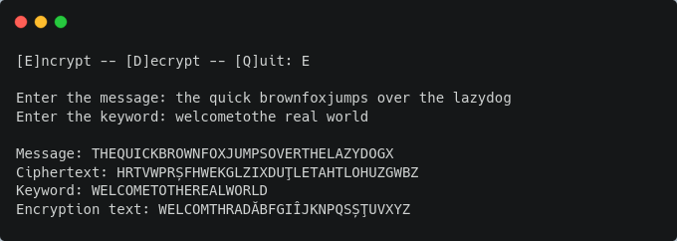
Figure 1: Text encryption output
When selecting the Encrypt option the user is prompted to enter a message, in this case the message is “the quick brownfoxjumps over the lazydog” with the keyword “welcometothe real world”. The encrypted version of the text is “HRTVWPRȘFHWEKGLZIXDUȚLETAHTLOHUZGWBZ”.

Playfair Decryption
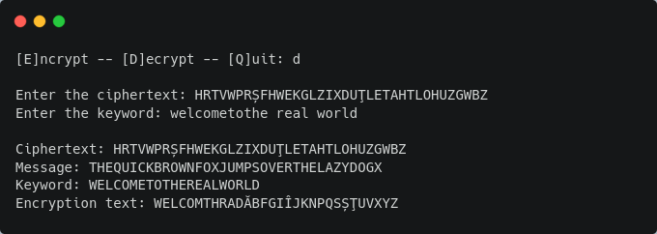
Figure 2: Text decryption output
When selecting the Decrypt option the user is prompted to enter the cyphertext (note: the scipt will output an error if the length of the ciphertext is odd) and the keyword. When decrypting the ciphertext “HRTVWPRȘFHWEKGLZIXDUȚLETAHTLOHUZGWBZ” with the keyword “welcometothe real world” the message is “THEQUICKBROWNFOXJUMPSOVERTHELAZYDOGX”.
Conclusions:
In summary, the Playfair cipher is a classical symmetric key cryptographic algorithm characterized by its utilization of a 5x5 (adaptible to other alphabets) key matrix to encrypt plaintext messages. Its strength lies in its ability to efficiently encrypt digraphs (pairs of letters) while providing resistance against basic frequency analysis attacks. Although it lacks the robustness of modern encryption algorithms, the Playfair cipher remains a valuable historical artifact in the field of cryptography.
References:
1. Github repository: https://github.com/muffindud/CS_Lab/tree/lab3/lab3

